Week 8 Tutorial – Human Aspects

Human and organizational factors in computer and information security are discussed in some detail in the article Human and organizational factors in computer and information security: Pathways to vulnerabilities by Sara Kraemer, Pascale Carayon and John Clem.

Question 1) Report Back on the IT Security Role
Search the internet (for example in trademe.co.nz or seek.co.nz) for IT jobs that include the word “security”. Choose a favourite in your pairs and summarise the type of security activities and tasks that you can find (select at least 5 different kinds of activities) included in the job descriptions.
Consider these tasks in relation to information security management frameworks and associate the tasks with a phase in the information security management framework:
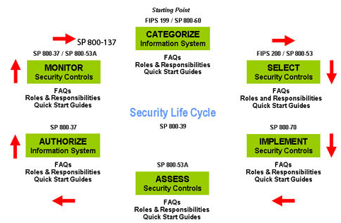

Review the IT Remuneration Report from l: Cyber Security Salary Guide: What Does Today’s Cyber Security Workforce Make? | Digital Guardian

Which group does your example job description belong to?

Question 2)
Select a practical security measure, such as content filtering of emails and web-site traffic (spying on) in the workplace. Consider the following question:

(i) Who would be likely administrator of the security measure?
(ii) Would this work give the person access to sensitive information they did not have previously?
(iii) Is the security measure worth implementing despite the new risk?
(iv) Why would staff like / or not like the solution (would it limit their freedoms, expose their personal data...)?
(v) How would you convince everyone about the benefits of this new tool?

